Presented by: Mr. Rehman Ali (K190801)

Ms. Monika (K170839)

Mr. Santanu Singh (K190133)

Mr. Kasun Madhushanka (K191289)

Presented to: Mr. Syed Altaf

Final project report  
Assessment - 3

Green Thumb Gardening

Table of Contents

Introduction 2

Background 2

Purpose 2

Objectives 2

Scope and Limitations 2

Assumptions 3

Key deliverables 3

System Requirements 3

Functional requirements: 3

Nonfunctional requirements 5

System Architecture 6

Software Architecture: 7

7

System design 7

User interface 7

Use case Diagram 11

Context Diagram 12

Data Flow Diagram Level 1 12

Level 2 DFDs 13

Sequence Diagram 16

Databases structures: 20

Entity relationship diagram: 21

References 22

# Introduction

## Background

Green Thumb Gardening is a leading plant and seed selling company that approach their customers with wide range of additional services such as garden maintenance tools and services. From the back end of the business they are running it manually with some advertisements on the social media. Due to COVID19 restrictions they can only have limited number of employees as well as limited number of customers at a time. As the solution business owners came up with a solution to digitalize the manual system which leads to increase the service reachability to the customers due to the COVID19 restrictions/ limitations and as well as the new trend by being most of the customers are prefer to do online shopping than visiting the shop.

## Purpose

This report formalizes the requirements that will needed for the implementation of Green Thumb Gardening online ordering system, deployment needs, architectural designs and the deliverables by and from the system are attached in this project report. Completion of this project enables the customer to order their products and services online and make payments online without any interactions with the employees or public prior to service. Also this system will be beneficial for customers as well as to the business. For the business, through this system there can be done some reductions on the employee wages and for the customers, they can shop online from anywhere from any internet enabled device.

## Objectives

The deployment has the following key objectives,

* Customer should be able to order products and services online.
* Customer should be able to make the payments online.
* Customer should be able to rate and give the feedback online.
* Employee should be able to order, update and check the inventories online.
* Employee should be able to generate reports through the new system.
* System should simplify the daily operations and managerial tasks.

## Scope and Limitations

**Scope**

* Study the current operations and progress they making with current system using online resources.
* The implementation of the website has to be finished within specified time frame.
* During the project, between project development team and between the team and the customer should have a better frequent communication with the updates.
* As the first deployment of the website it will only allow the most essential basic functionalities.

**Limitations**

* For the implementation there will be limited data access as it has been operated manually.
* Also it will be limited on methods to collect the data and data collection process.
* To accomplish the project there will be a limited time constraints.
* Lack of human resources for the completion of the project.

## Assumptions

* After completion of this project, it will be able to meet the specified goals in the objectives.
* Towards the completion of this project the team has all the resources and skills.
* The website must meet all the written specifications, be thoroughly tested, and be completed on time.
* Through the system reports administration should be able to predict and make the sales decisions.

# Key deliverables

The key deliverables of the green thumb gardening project are:

* The user will be able to open new account by registering in the system and login to the system with the valid details
* The user will be able to view the brief details of all the products and List out all the products
* The user will be able to view delivery charges, the availability of the store, the discounted product along with the services provided
* The user will be capable of listing out particular product for particular service and give feedback/ review for services or products
* The user will be capable of selecting rating for services and check business hours
* The user will be capable of hiring gardener and mower from the website.
* The user will be able to make necessary modifications such as edit the date, place , time needed services and or edit job description
* The user will be capable of browsing all the products of the website.
* The admin will be able to add, edit and delete the users whenever they want.
* The report of the users, products or the services should be generated by the admin. The generated report can be of monthly, weekly or daily.

# System Requirements

## Functional requirements:

The expectations of the system are expressed by functional requirements under specific conditions. For accomplishment of tasks of user, the developers must enable the functional requirements. Following are some of the identified functional requirements for the online green thumb gardening store.

|  |  |  |
| --- | --- | --- |
| **Serial no.** | **Functional requirements** | **Comments** |
| **For user**: | | |
| 1 | Sign in | Allow user to sign in if they are not members yet. |
| 2 | Login details | Show the login page and enter the unique username and password. |
| 3 | Forgot/Reset password | Allow user to change password at any time. |
| 4 | List out products | Allow user to list out all the products that are available on website. |
| 5 | View product details | Allow user to check the details of products, specification, and availability. |
| 6 | View store availability | Allow user to find stock availability in specific store. |
| 7 | View discounted products | Allow user to check the limited time offers and half price items. |
| 8 | View available services | Allow user to view and choose the available services like landscaping, mowing, gardening |
| 9 | Review/Feedback | Allow user to post feedback or reviews for the purchased material and services provided. |
| 10 | Select rating | Allow user to choose relevant rating from five star. |
| 11 | Check business hours | Allow user to check the business hours for weekdays, weekends and public holidays |
| 12 | Hire Services | Allow user to choose the required services and can add location, time, date service required. |
| 13 | Edit job description | Allow user to enter into system and can edit the job description any time. |
| 14 | View delivery charges | Allow user to check the shipping charges and shipping times of the products. |
| 15 | Payment form | Allow user to pay online by various payment modes like apple pay, PayPal, credit/debit card. |
| **For admin:** | | |
| 1 | Admin login | Allow admin to enter the system with login details. |
| 2 | View user | Allow admin to delete, view, add, edit or view user at any time. |
| 3 | Forgot password | Allow them to change password at any time. |
| 4 | Dashboard | Allow them to show dashboard to user, showing all the available garden materials and tools. |
| 5 | Statics | Admin will able to see statics of the sales. |
| 6 | Manage user request | Allow them to accept the request and perform action based on user request. |
| 7 | Add products and services | Allow them to manage the purchase, add the new products, and return activities of material with user. |
| 8 | Logout | Allow them to logout from system at any time. |

## Nonfunctional requirements

The characteristics of the developed system is developed by non- functional requirements. Following are some of the non-functional requirements of the developed system:

1. **Security**:

* Only the members with valid details will able to perform activities like hire service or purchase tools.
* Unique username and password will be provided to each user.
* If the user entered incorrect details for three times, the system will lock their account for specific time.

2. **Availability**:

* System will be available for 24 hours.
* Customer care service will run 24/7 for any hindrance.
* Website will be opened by any browser with a secure connection.

3. **Performance:**

* System will capable of handling certain workload and will respond quickly to user action under this workload.
* Even if 20 thousands users accessing system same time it will perform effectively even if the users are increased.
* Performance consists of maintainability, availability as well as reliability.

4**. Scalability**:

* The system will be scalable if the user are increasing.
* The system will support more customer’s details as well as services and product details.

5. **Usability**:

* The developed system will be easy to use.
* The layout of website will be designed according to easy access for user.

6. **Reliability:**

* Under predefined conditions the system will effectively without any failure for given period of time.
* For example if the designed system has probability percentage for 2 months, the system will work effectively during this time under normal usage conditions.

7. **Maintainability**:

* System will be maintainable and its components will be fixed in required time.
* System will be adaptable to changing environment and increasing performance.
* For example if the system have maintainability of 85% for 20 hours so the system will be fixed to 85% in 20 hours of time period.

# System Architecture

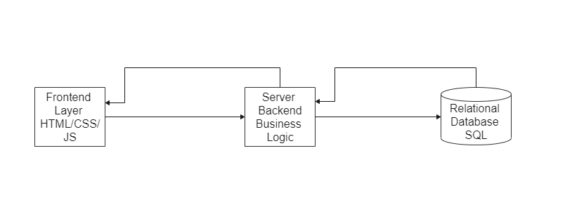

The System that we proposed is basically a 3-tier architecture-based system

**Frontend Layer:**

It consists of the web pages and its component; a user can utilize this layer to process his/her request to the system.

**Backend Layer:**

This layer consists the main business logic. I.e. Validation, cost calculation, CRUD operations, stock management and report generation.

Server-side layer is also responsible to connect database and frontend layer.

**Database:**

The database layer stores all the necessary data related to the system i.e. customer credentials, order details, stock details and etc.

## Software Architecture:

## 

These are some essential components of the software architecture:

* The frontend layer is divided into Customer view and Staff View
* Order processing, payment, invoice components are encapsulated in backend layer it handles the order processing business logic and operations i.e. Calculating costs, payment gateway and generating Invoices.
* Admin/Staff Panel Component keep tracks of all the orders, invoices and keep the stock availability.

# System design

## User interface

User interface (UI) is a process designer who uses software or computers to create interfaces that rely on looks or styles. Designers seek to build interfaces that are simple and enjoyable for consumers. The architecture of a user interface is graphical users and other modes — for example, voice-controlled interfaces. A strong user interface offers a user-friendliness environment that enables the user to communicate naturally and intuitively with the program or hardware. The user interface design for the provided case scenario are given below:

1. **Sign up**

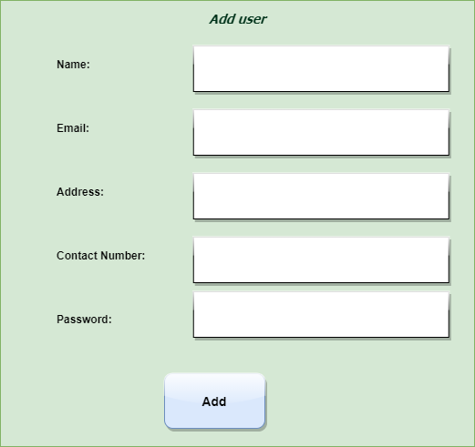

1. **Login**

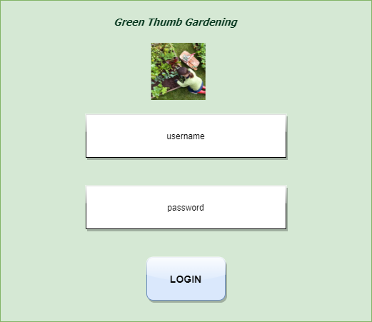

1. **Home page**

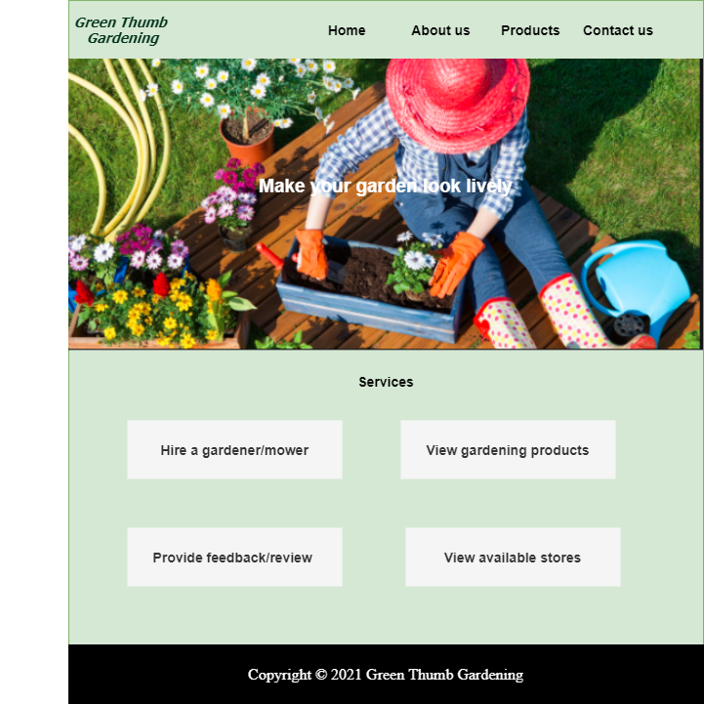

1. **Viewing list of products / search products**

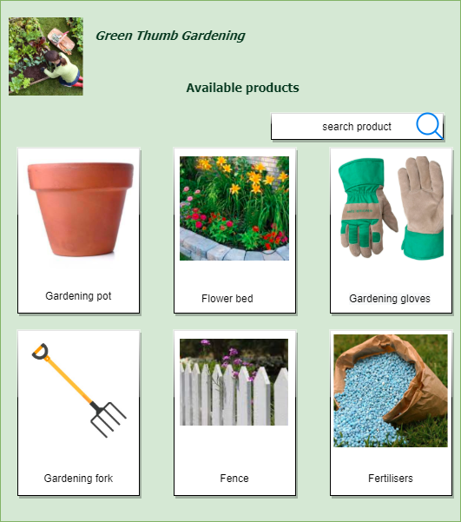

1. **Making payment**

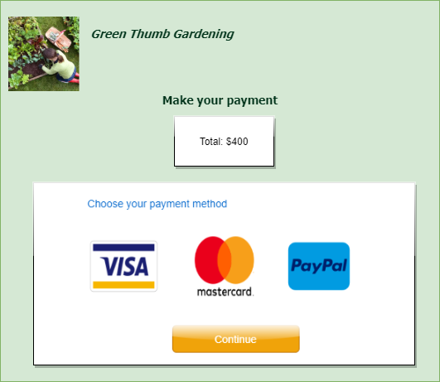

1. **Hire a gardener**

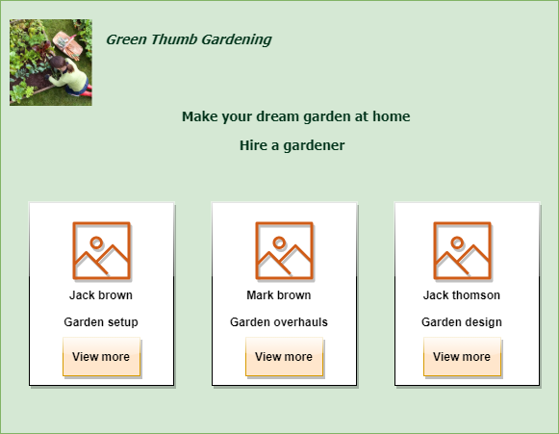

# Use case Diagram

Use cases were typically called behavior charts that illustrate a series of activities (use cases) that should be carried out by a system or processes (subject) in conjunction with one or more external users of the system (actors). Each case of application should give the actors or other device players some measurable and useful results. The diagram is intended to capture the system's complex appearance. The term is too general, however, to explain the intent since there is also the same purpose in other four diagrams (activity, sequence, cooperation, and charts). This diagram will assist to understand the features and needs of the system along with the missing components of the proposed system. The actor for the given system are user and admin. The use case diagram is shown below:

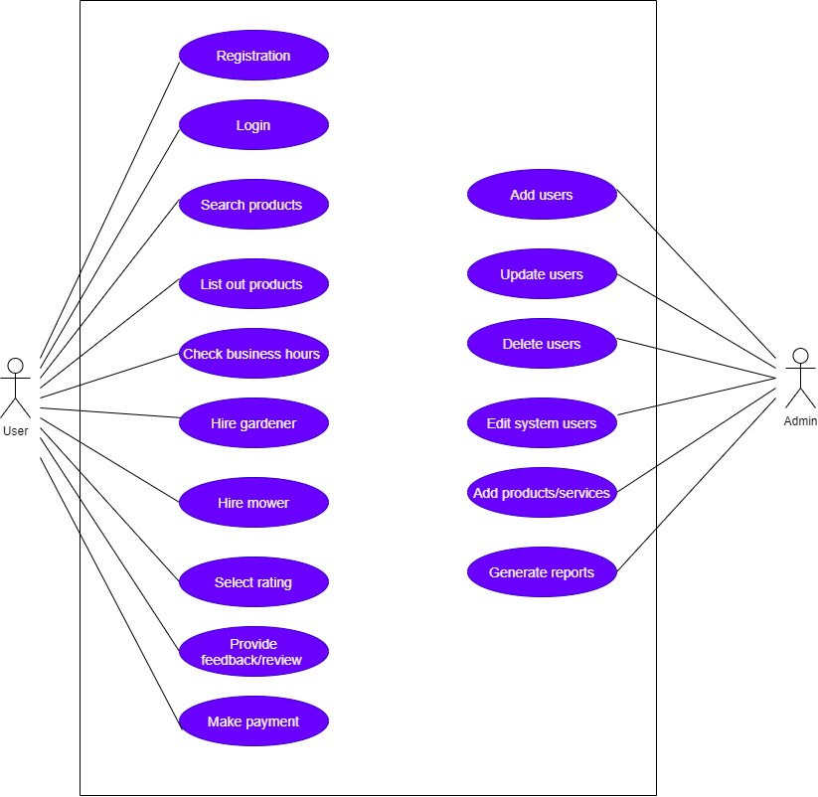

# Context Diagram

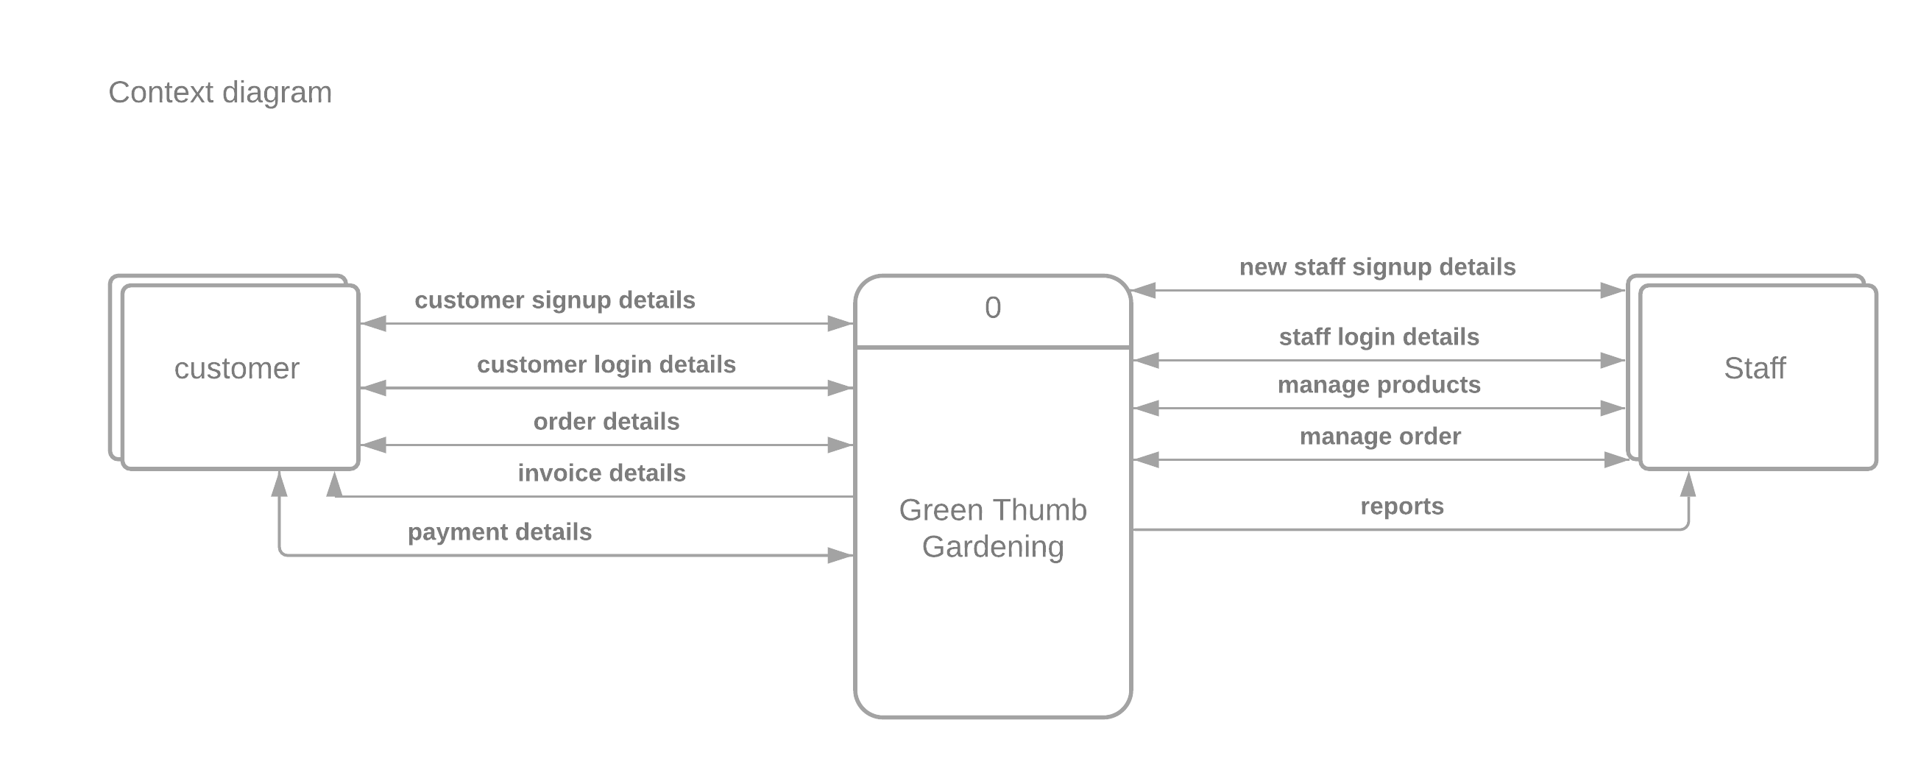

# Data Flow Diagram Level 1

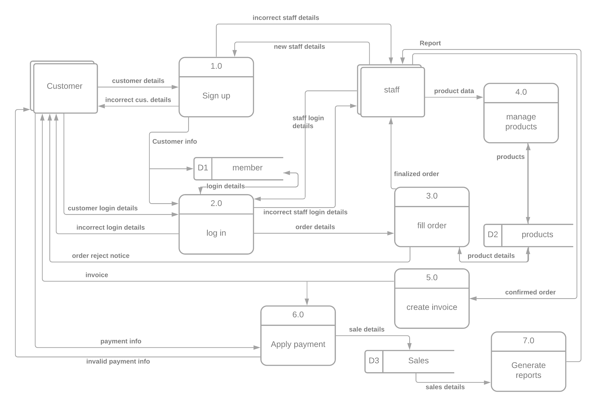

# Level 2 DFDs

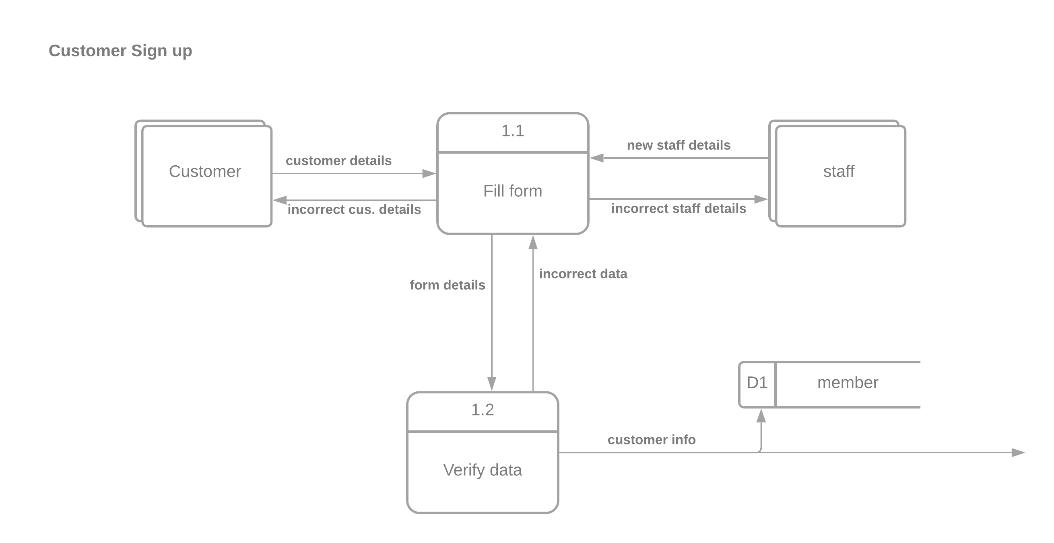

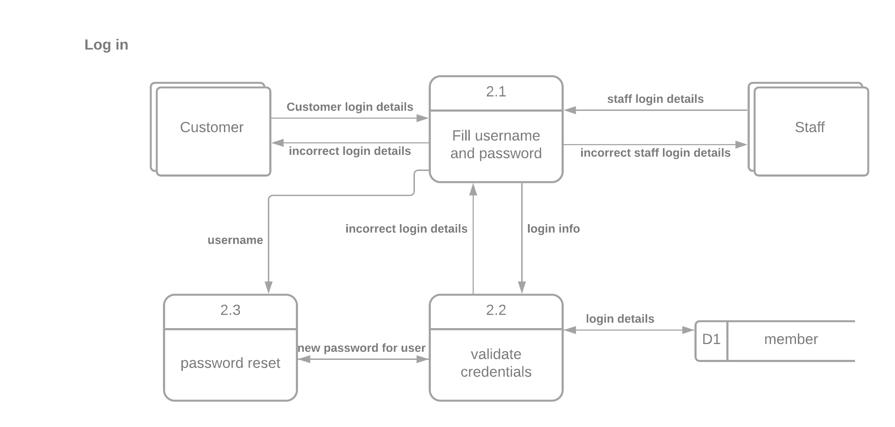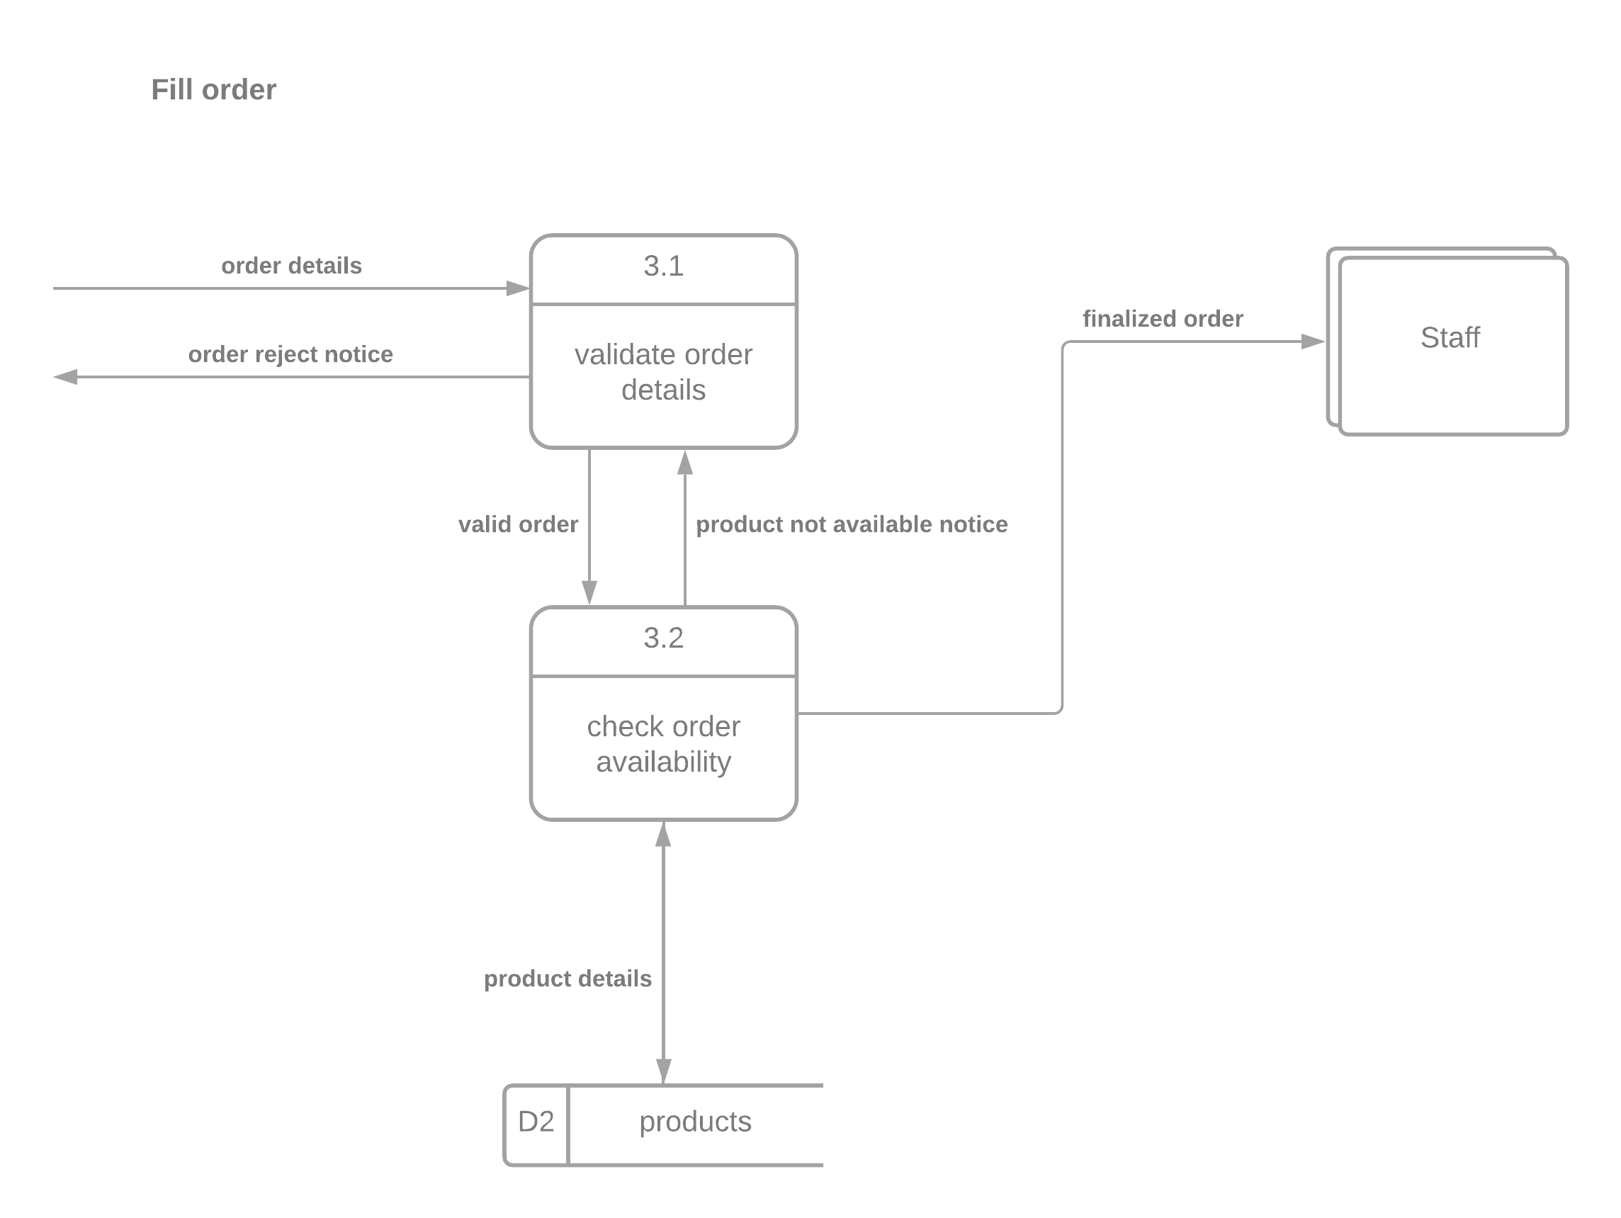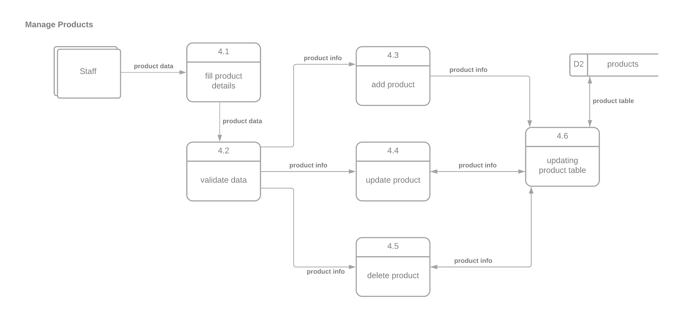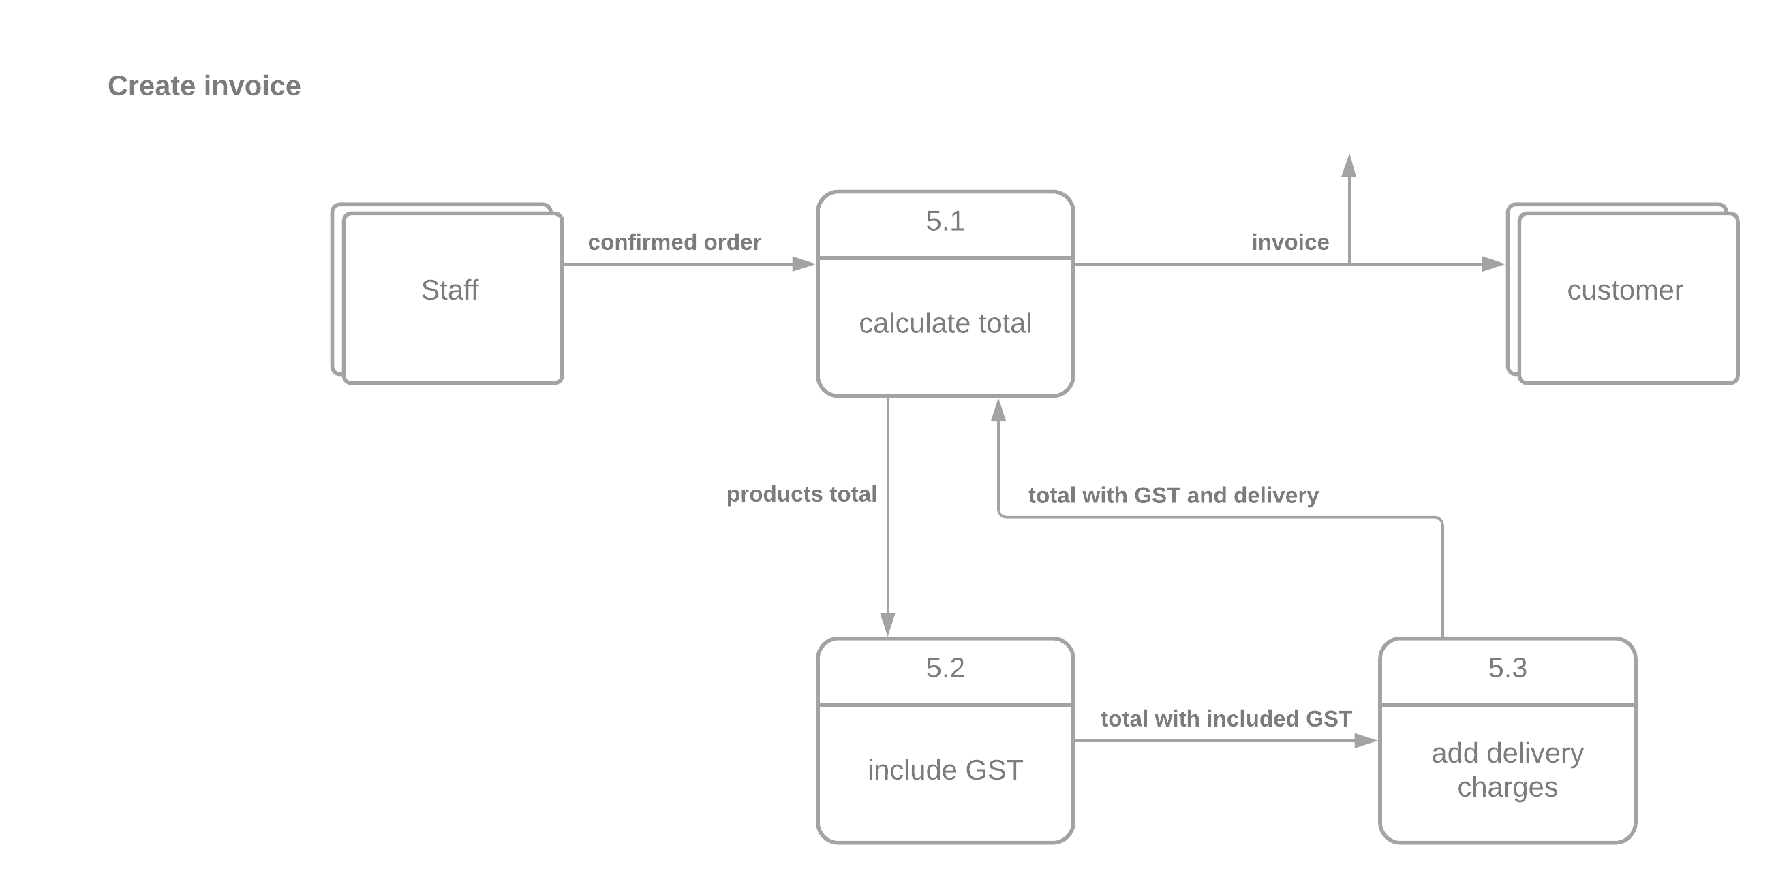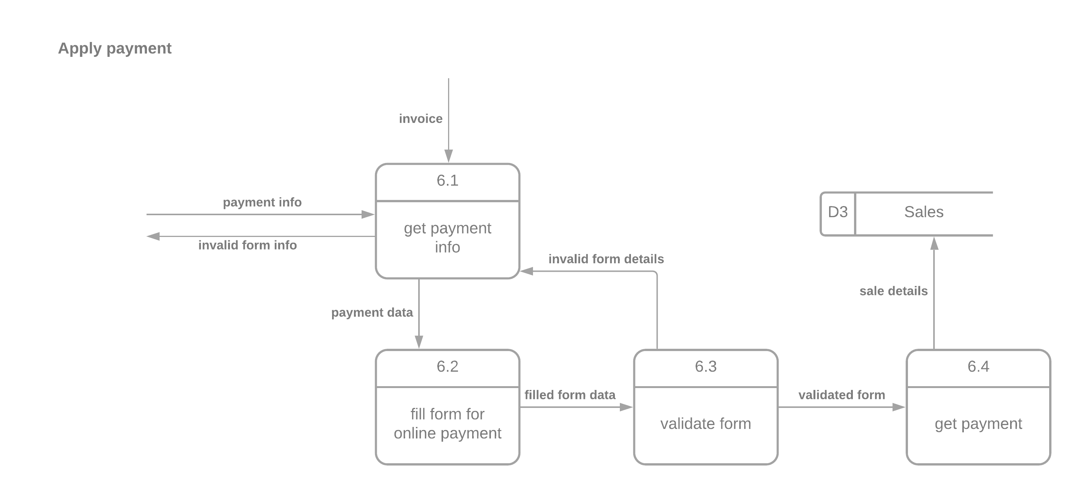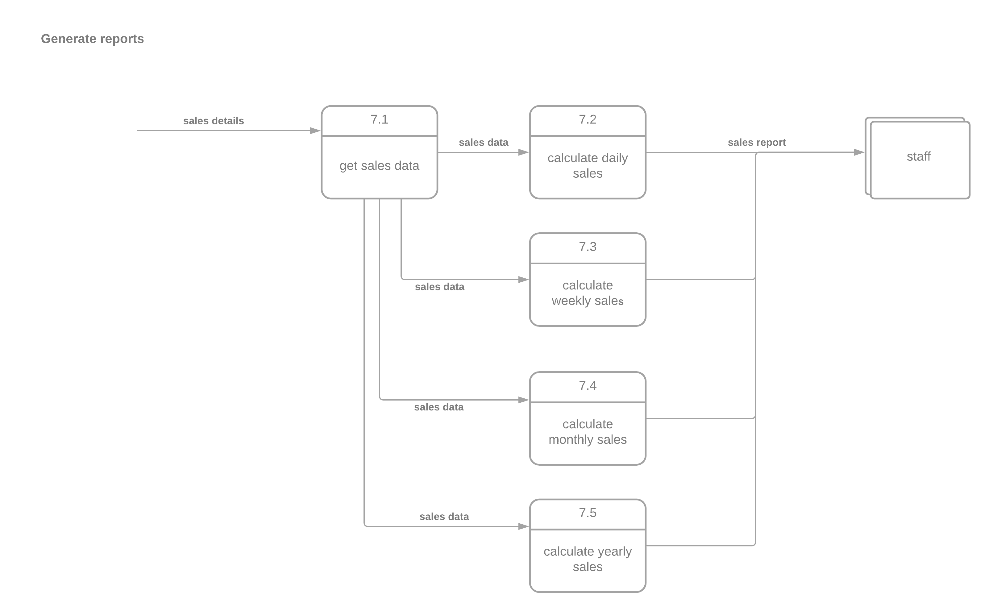

# Sequence Diagram

1. **Customer Signup / Account Creation**

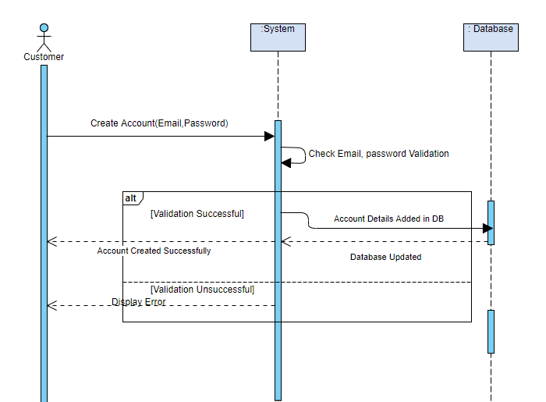

1. **Customer login**: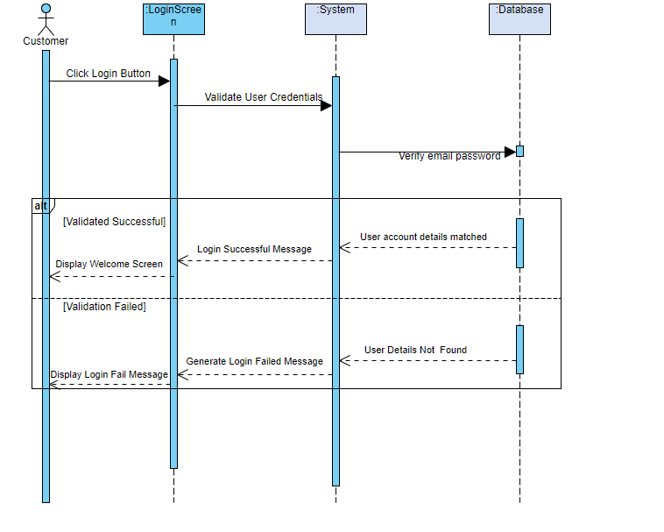
2. 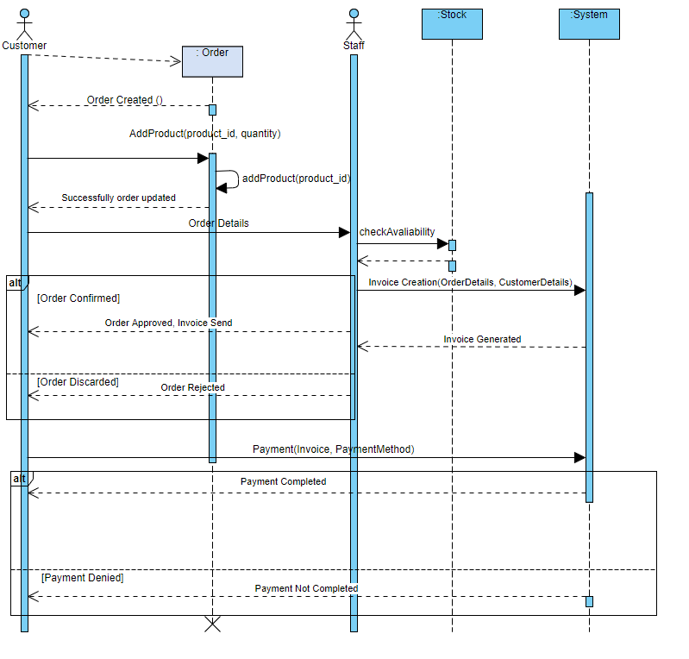**Customer Order Placement and Payment with staff approval/rejection:**
3. 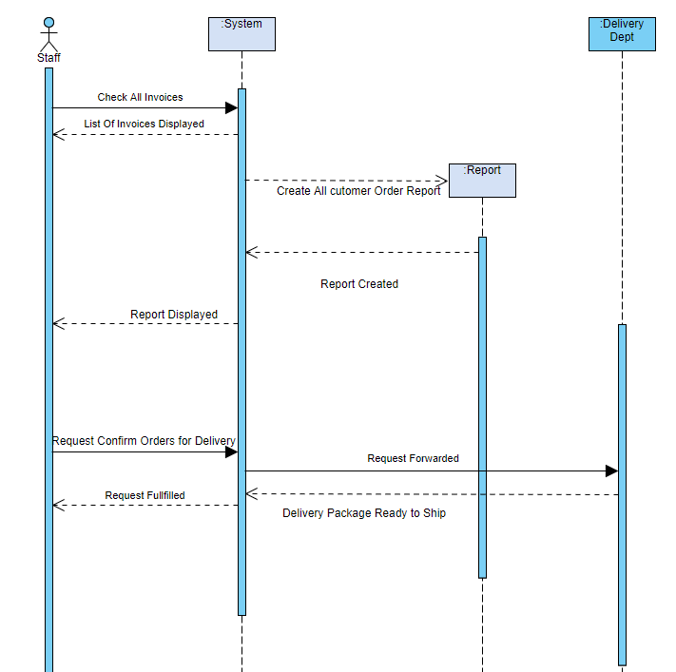**Staff order delivery and report generation**

# Databases structures:

|  |  |  |
| --- | --- | --- |
| **Sno** | **Stock** | **Type** |
| 1 | Id | int |
| 2 | Product Id | int |
| 3 | Quantity (Qty) | int |

|  |  |  |
| --- | --- | --- |
| **Sno** | **User Master** | **Type** |
| 1 | User Id | int |
| 2 | Username | Varchar |
| 3 | Email id | Varchar |
| 4 | Address | varchar |
| 5 | Contact Number | numeric |
| 6 | Password | varchar |

|  |  |  |
| --- | --- | --- |
| **Sno** | **Product** | **Type** |
| 1 | Product Id | int |
| 2 | Name | Varchar |
| 3 | Price | Float |
| 4 | Desc | varchar |

|  |  |  |
| --- | --- | --- |
| **Sno** | **Order** | **Type** |
| 1 | Order Id | int |
| 2 | Payment id | int |
| 3 | Product id | int |
| 4 | Qty | Float |
| 5 | User Id | int |

|  |  |  |
| --- | --- | --- |
| **Sno** | **Payment** | **Type** |
| 1 | Payment Id | int |
| 2 | Order id | int |
| 3 | Payment | Float |
| 4 | Type | varchar |

|  |  |  |
| --- | --- | --- |
| **Sno** | **Feedback** | **Type** |
| 1 | User Id | int |
| 2 | Order id | int |
| 3 | Rating | Varchar |
| 4 | Remarks | Varchar |

## Entity relationship diagram:

* ER Diagram is associate entity relationship diagram which offer user to visual understanding for system.  
  What is Entities.  
  An entity could be an illustration of a category of object. It is often a student, order, thing, etc.
* Entities typically have attributes that describe them.  
  In crow’s foot notation, associate entity is portrayed by a parallelogram, with its name. The name is singular instead of plural (entities).
* 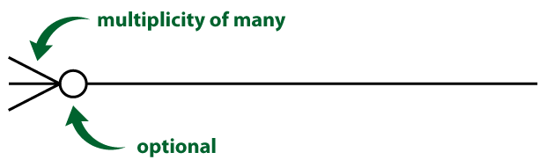zero or many
* 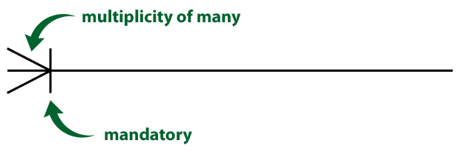one or many
* 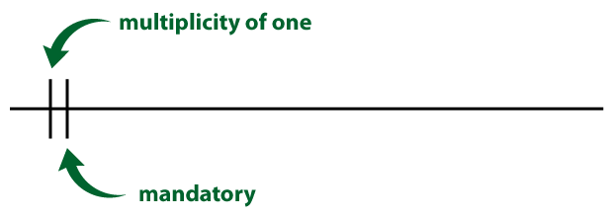one and only one
* 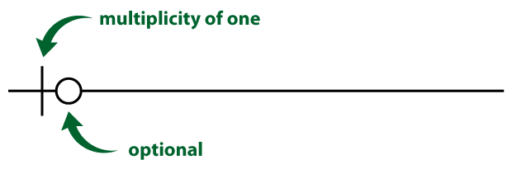zero or one

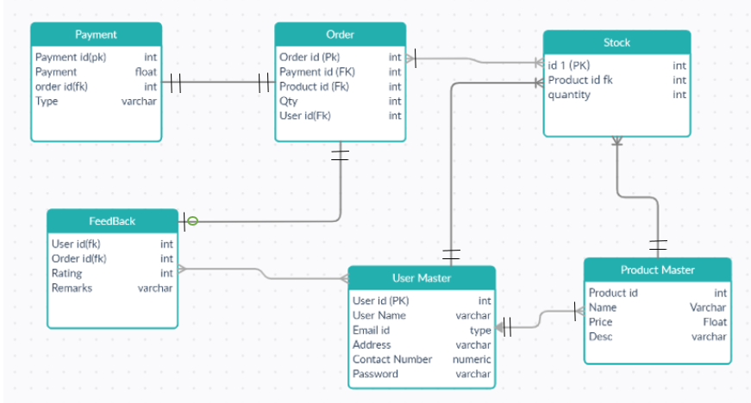

# References

1. Lucidchart. 2021. *What is a Data Flow Diagram*. [online] Available at: <https://www.lucidchart.com/pages/data-flow-diagram> [Accessed 17 April 2021].
2. Project Management Institute. 2020. *What is Project Management?*. [Online] Available at: <https://www.pmi.org/about/learn-about-pmi/what-is-project-management>[Accessed 17 April 2021].
3. Alexander, M., 2019. *What is a project manager? The lead role for project success*. [Online] CIO. Available at: <https://www.cio.com/article/3224865/what-is-a-project-manager-the-lead-role-for-project-success.html> [Accessed 17 April 2021].
4. Ryan, M. (2011). On the Use of a Project Purpose Statement in Developing Stakeholders Requirements [Accessed 17 April 2021].
5. Shehu, Z., & Akintoye, A. (2010). Major challenges to the successful implementation and practice of programme management in the construction environment: A critical analysis. International Journal of Project Management, 28, 26–39. <https://doi.org/10.1016/j.ijproman.2009.02.004>
6. Dr.S.S.Riaz, A. (2010). Project Planning: An Analysis. International Journal of Engineering Science and Technology, 2